**Therese-Volunteer Story**

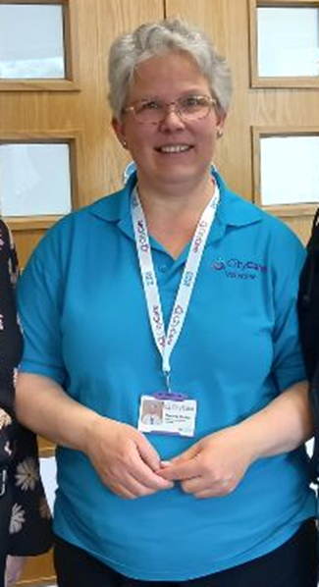

My name is Therese, I am currently volunteering with Nottingham City care Partnership at St Ann’s Health Centre once a week, and my role is to provide administrative support to the teams.

Initially, the thought of switching from the retail sector to an administrative role was daunting, but I built up confidence and started job searching. After spending time researching Nottingham CityCare, I was very impressed and applied for a volunteering placement.

Since starting my volunteering placement at Nottingham CityCare, I have greatly enjoyed the skills and knowledge I have gained through a variety of tasks, including communicating and meeting new people. Not only is the placement greatly beneficial, but also the process of applying and interviewing for the role has meant I have now built-up confidence when applying for new jobs.

Having a disability myself, I am particularly impressed with Nottingham CityCare and the way they promote being a Disability Confident company and the way they pride themselves on their key values – Kindness, Respect, Trust, and Honesty.

In my daily life, I communicate with spoken English language and primary and visual British Sign Language. Because of this, it is so important for a workplace to show inclusivity and to care and support with the ways I communicate.

Sign Language promotes the social inclusion by breaking down communication barriers and maintains good connections on both sides. Wearing my cochlear implant means I can hear advanced sounds, including communication tones and understanding what individuals and groups are talking about.

Furthermore, I have noticed the way Nottingham CityCare aim to include all staff and offer great support. CityCare had even provided me with British Sign Language’ interpreters, so that they interpret to translate into the sign language for me to access the information in the meeting and training. I can say that because of this, I have felt settled and so happy in my role as a volunteer at Nottingham CityCare.

I started to volunteer at St Anns Health Centre last October 2023, and I am still in my role today. I’ve gained great experience with the administrative work, effective communication skills with the team, and the inclusive environment that the staff have worked hard to make for someone with a hearing disability. The team are brilliant to work with, they show great empathy, and they do everything they can to make communicating easier for me.

The volunteering placement at Nottingham City care Partnership has exceeded my expectations with what I have learnt in administration. Thanks to CityCare, I believe there is no stopping and holding me back where I can go, especially with my disability and language. I now recommend to any individuals who have disability, who are deaf, hard of hearing or with language barriers, to volunteer with Nottingham City care.

Thank you, Nottingham CityCare, for showing a great standard of values, behaviours, and following equality of opportunity. We are all working together to improve equality, diversity, and inclusivity.

