Workforce Race Equality Standard (WRES): Annual Report 2023
- Introduction
Commissioned by the NHS Equality and Diversity Council and NHS England, the WRES is underpinned by engagement with NHS and national healthcare organisations. The Equality & Diversity Council adopted the WRES as the best means of helping the NHS to improve its workforce race equality performance. There is considerable evidence that the less favourable treatment of Black and Minority Ethnic staff has a significant impact on wellbeing, patient outcomes and on the efficient and effective running of the NHS.
The NHS WRES was made available to the NHS from April 2015, is included in the NHS standard contract with annual publication of reports. The main purpose is to help organisations review data against the WRES indicators, to produce action plans which will close the gaps in workplace experience between White and Black and Minority Ethnic (BME) staff and to improve BME representation in organisations and at Board level.
- Executive Summary

The WRES data is a snapshot taken on 1 April 2023, reporting on the period 1.4.22 to 1.4.23. The report also compares to the previous reporting period shows:

There has been a slight increase in the number of BME staff in the organisation to 14.80% and there has been a slight decrease in the amount of staff self-reporting their ethnicity to 99.42%.

Compared to the whole workforce, within AfC pay bands 2-8a, the highest percentage of BME staff remain in AfC band 6. AfC band 8a is at 3%, which is a decrease from the previous year. BME staff in Very Senior Manager (VSM) posts remains at 0.6%.

There has been a decrease in the percentage difference between BME membership of the Board and the workforce. Bullying, harassment and discrimination have increased for BME colleagues compared to the previous reporting period.

Bank staff data shows that overall there was a total of 237; 87% women, 12% men (with 1 undisclosed gender). Bank staff were across AfC pay bands 2-7. There were 70% White Staff and 5% Mixed Ethnicity, 14% Asian/Asian British, 4% Black/Black British, 4% Other Ethnicity and 3% Not Stated. There is a proportionately higher amount of Black and Asian Minority Ethnic Bank staff at 30% than substantive staff at 14.80%.

No Bank staff have entered into the formal disciplinary process or have been dismissed during the reporting period.
Data remains the same as the previous year for BME staff entering the formal disciplinary process at nil and an increase in the recruitment of BME candidates from shortlisting. There has been an increase in the percentage of BME staff believing the organisation provides equal opportunities in career progression or promotion.

- Progress

There has been a slight increase in the number of BME staff in the organisation by +0.16% to 14.80% and there has been a slight decrease of -0.40% in the amount of staff self-reporting their ethnicity to 99.42%.

Compared to the whole workforce, within AfC pay bands 2-8a, the highest percentage of BME staff remain in AfC band 6 at 29% and AfC band 8a is 3%, which is a decrease from the previous year by -1%. BME staff in Very Senior Manager (VSM) posts remains at 0.6%.

There has been a decrease in the percentage difference between the Board voting members and the overall workforce by -3.49%, membership of the Board by -11.27% and voting members of the Board by -16.66%

There has been a positive response in:

- The proportion of BME staff employed in CityCare by +0.16% to 14.80%
- The likelihood of BME candidates being appointed from shortlisting at a ratio of 0.96 showing proportionately more BME candidates were appointed than White candidates. BME candidates appointed 64%, an improvement of +25% on the previous year. White candidates appointed from shortlisting was 62%.
- Staff believing the organisation provides equal opportunities in career progression/ promotion for BME staff by +2% and White staff by +1%

Remains the same:

- White staff are 4 times more likely to enter the formal disciplinary process and no BME staff members entered the process
- The likelihood of BME and Wite staff accessing non-mandatory training remains the same as the previous reporting period at White staff being 1.03 times more likely to access
There has been a less positive response in:
- Bullying & harassment for BME staff from patients/public has increased by +3% to 22% with a reduction for White staff of -4% to 18%
- Bullying & harassment for BME staff from colleagues has increased by +2% to 27% and reduced for White staff by -2% to 10%
- Discrimination from manager/team leader/colleague by +6% to 18% for BME staff and for White staff an improvement by -1%
- percentage difference between the Board voting members and the overall workforce by -3.49%, membership of the Board by -11.27% and voting members of the Board by -16.66%

- Conclusion
The WRES shows slight improvement in the amount of BME staff employed in CityCare. There is significant improvement in the likelihood of BME candidates being appointed from shortlisting compared to White staff and compared to the previous year. There is also improvement in Staff believing the organisation provides equal opportunities in career progression/ promotion for BME and White staff. We have no BME staff entered into our formal disciplinary process.
There is a less positive response in bullying & harassment and discrimination for BME staff than the previous year. There has also been a decrease in BME members of the Board compared to the previous reporting period.
Priority actions are aligned with CityCare Strategy, CityCare’s Workforce EDI Strategy, the Integrated Care System priorities and the Midlands Race Equality and Inclusion Strategy. We will work with our BAME staff network to progress agreed actions.
We will continue with our priorities including reviewing and refreshing our recruitment policy & processes to ensure inclusivity and increased representation of diversity, develop systems to identify talent, support productive conversations about race and promote anti-racism within the organisation, embed EDI within leadership and people management programmes, offer mutual mentoring and Aspiring Leaders programmes and develop a talent management process.

Workforce Race Equality Standard

Date of this report | May 2023
Name of Provider Organization | Nottingham CityCare Partnerships
Name and Title of Board Lead for Workforce Race Equality Standard | Helen Marks Director of People, Communications & Inclusion
Name and contact details of Lead Manager completing this report | Fiona Cambridge Equality Diversity & Inclusion Lead  f.cambridge@nhs.net
Name of Commissioners this report has been sent to | NHS Nottingham & Nottinghamshire Integrated Care Board

Report on the WRES Indicators
- Background Narrative
- Any issues of completeness of data
None

- Any matters relating to reliability of comparisons with previous years
None

- Total Numbers of Staff
- Employed within this organisation at the date of this report
1198 (previous year 1120)

- Proportion of BME staff employed within this organisation at the date of this report
14.80%
3. Self-Reporting
- The proportion of total staff who have self-reported their ethnicity

99. 42%

- Have any steps been taken in the last reporting period to improve the level of self-reporting of ethnicity

Staff complete self-reporting on application, at recruitment and for the staff survey. Regular awareness raising to staff on the importance of using self-serve to add personal data.

- Are any steps planned during the current report period to improve the level of self-reporting by ethnicity

Continue to raise awareness of the importance of recording during equality training, on the website and in CityCare Cascade

- Workforce Data
- What period does the organisation’s workforce data relate to?

April 2022 to April 2023 (exception indicator 3 which is a rolling two-year period)

5. Workforce Race Equality Indicators
 | Indicator  For each of these four workforce indicators, the Standard compares the metrics for White and BME staff | Data for reporting year | Data for previous year | Narrative – implications of this data and background narrative
1 | Percentage of staff in each of the AfC bands 1-9 or medical and dental subgroups and VSM (including executive board members) compared with the percentage of staff in the overall workforce disaggregated by:  - Non clinical staff  - Clinical staff of which:  - Non-medical  - Medical & dental  Definitions are based on ESR occupation codes with the exception of medical & dental staff | Band 1 non-clinical  Nil | Band 1 non-clinical  Nil | The overall proportion of BME staff employed in the organisation has increased from 14.64% to 14.80%  Band 6 has highest percentage of BME staff within the whole workforce at 29% however this is a decrease of 3% of from the previous reporting period.  Within bands 2-8a, band 8a has the lowest amount of BME staff within the whole workforce at 3%. This is a decrease from the previous year of 1%.  There has been an increase in BME staff within  - Band 2 non-clinical  - Band 4 clinical  - Band 6 clinical and non-clinical  - Band 7 clinical  - Band 8a clinical  % compared to the whole BME workforce shows:  - there are more BME staff than last year in bands 4 and 7  - bands 2 and 3 remained the same as last year  - there were less BME staff in bands 5, 6 and 8a than last year  National WRES data published in 2022 shows  - as of 31 March 2021, 22.4% of staff working in the NHS trusts in England ere from a BME background. This is an increase from 19.1% in 2018  - the total number of BME staff at very senior manager level has increased by 69.7% since 2018
 |  | Band 2 non-clinical  BME 30%  White 70%  Band 2 clinical  BME 8%  White 92%  B2 % BME in overall workforce 13% | Band 2 non-clinical  BME 29%  White 71%  Band 2 clinical  BME 8%  White 92%  B2 % BME in overall workforce 13%
 |  | Band 3 non-clinical  BME 10%  White 90%  Band 3 clinical  BME 14%  White 86%  B3 % BME in overall workforce 12% | Band 3 non-clinical  BME 13%  White 87%  Band 3 clinical  BME 14%  White 86%  B3 % BME in overall workforce 12%
 |  | Band 4 non- clinical  BME 14%  White 86%  Band 4 clinical  BME 18%  White 82%  B4 % BME in overall workforce 18% | Band 4 non- clinical  BME 14%  White 86%  Band 4 clinical  BME 12%  White 88%  B4 % BME in overall workforce 14%
 |  | Band 5 non-clinical  BME 9%  White 91%  Band 5 clinical  BME 18%  White 82%  B5 % BME in overall workforce 16% | Band 5 non-clinical  BME 27%  White 73%  Band 5 clinical  BME 18%  White 82%  B5 % BME in overall workforce 20%
 |  | Band 6 non-clinical  BME 18%  White 82%  Band 6 clinical  BME 16%  White 84%  B6 % BME in overall workforce 29% | Band 6 non-clinical  BME 12%  White 88%  Band 6 clinical  BME 15%  White 85%  B6 % BME in overall workforce 32%
 |  | Band 7 non-clinical  BME 6%  White 94%  Band 7 clinical  BME 9%  White 91%  B7 % BME in overall workforce 8% | Band 7 non-clinical  BME 6%  White 94%  Band 7 clinical  BME 7%  White 93%  B7 % BME in overall workforce 7%
 |  | Band 8a non-clinical  BME 15%  White 85%  Band 8a clinical  BME 25%  White 75%  B8a % BME in overall workforce 3% | Band 8a non-clinical  BME 40%  White 60%  Band 8a clinical  BME 18%  White 82%  B8a % BME in overall workforce 4%
 |  | Band 8b non-clinical  BME nil  White 100%  Band 8b clinical  BME nil  White nil | Band 8b non-clinical  BME nil  White 100%  Band 8b clinical  BME nil  White nil
 |  | Band 8c non-clinical  BME nil  White 100%  Band 8c clinical  BME nil  White nil | Band 8c non-clinical  BME nil  White 100%  Band 8c clinical  BME nil  White nil
 |  | Band 8d non-clinical  BME nil  White 100%  Band 8d clinical  BME nil  White nil | Band 8d non-clinical  BME nil  White 100%  Band 8d clinical  BME nil  White 100%
 |  | Band 9 non-clinical  BME nil  White nil  Band 9 clinical  BME nil  White nil | Band 9 non-clinical  BME nil  White nil  Band 9 clinical  BME nil  White nil
 |  | VSM non-clinical  BME 33%  White 67%  VSM clinical  BME nil  White nil  % BME in overall workforce 0.6% | VSM non-clinical  BME 25%  White 75%  VSM clinical  BME nil  White nil  % BME in overall workforce 0.6%
 |  | Medical subgroups  BME nil  White 100% | Medical subgroups  BME nil  White 100%
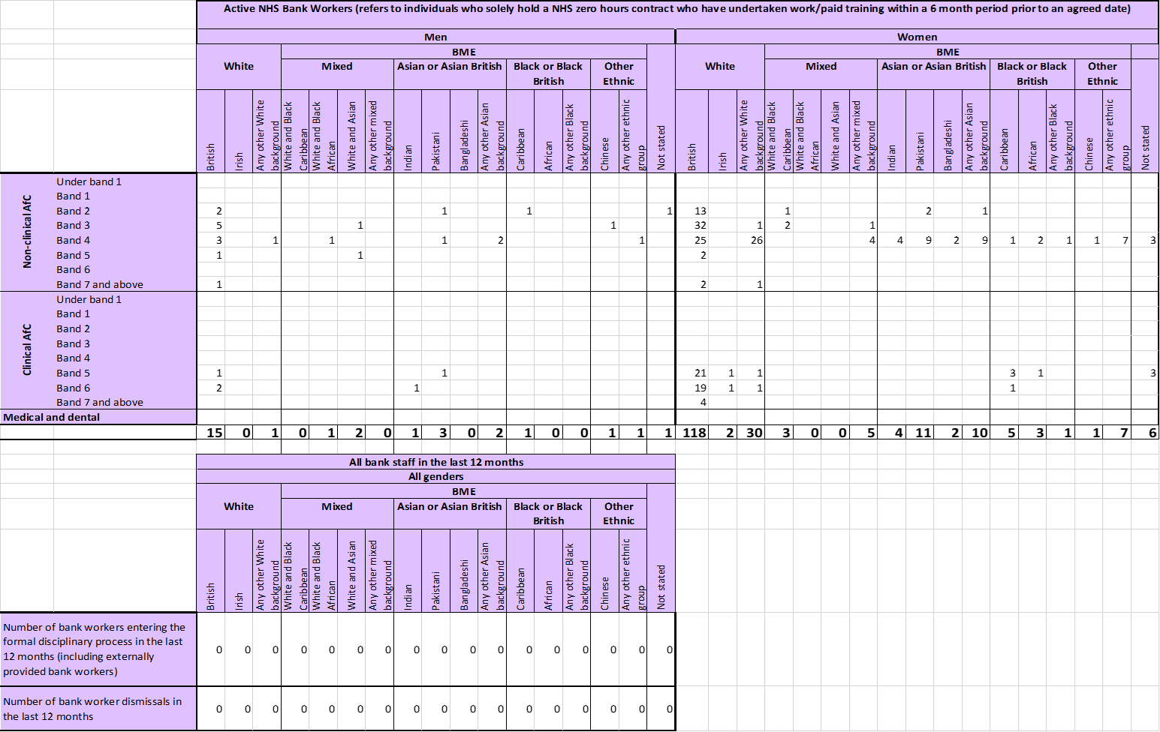

 | Indicator  For each of these four workforce indicators, the Standard compares the metrics for White and BME staff | Data for reporting year | Data for previous year | Narrative – implications of this data and background narrative
2 | Relative likelihood of BME staff being appointed from shortlisting compared to that of White staff being appointed from shortlisting across all internal and external posts. | Likelihood of White candidates being appointed from shortlisting is 0.96 times greater than BME candidates | 1.28 times greater than BME candidates | Compared to the previous reporting period, the likelihood of White candidates being appointed from shortlisting has decreased, whilst it has increased to be greater for BME staff than White staff.  64% BME staff were hired, 62% White staff were hired  National data published in 2022 shows white applicants were 1.54 times more likely to be appointed from shortlisted compared to BME applicants and this was lower than the previous year. CityCare’s data shows that BME candidates were more likely to be hired
3 | Relative likelihood of BME staff entering the formal disciplinary process, compared to that of White staff entering the formal disciplinary process, as measured by entry into a formal disciplinary investigation | White staff are 4 times more likely to enter the formal disciplinary process than BME staff | White staff are 2 times more likely to enter the formal disciplinary process than BME staff | For this reporting period, no BME staff have entered the formal disciplinary process  National data published in 2022 showed BME staff were 1.14 times more likely to enter the formal disciplinary process compared to white staff, which was also the same as the previous year. CityCare are above the national average with no BME staff entering the process
4 | Relative likelihood of BME staff accessing non-mandatory training and CPD as compared to White staff | 1.03 times more likely for White staff to access non-mandatory training than BME staff | 1.03 times more likely for White staff to access non-mandatory training than BME staff | The likelihood of BME and White staff accessing non-mandatory training has remained the same as the previous reporting period.

5 | KF 25. Percentage of staff experiencing harassment, bullying or abuse from patients, relatives or the public in last 12 months | White 18% | White 22% |  | There was a decrease of 3% for White staff experiencing bullying & harassment from patients & relatives while there was an increase for BME staff of 3%  National data published in 2022 shows 1 in 4 staff (25%) experienced bullying & harassment or abuse from the pubic, CityCare are below that percentage
 |  | BME 22% | BME 19%
6 | KF 26. Percentage of staff experiencing harassment, bullying or abuse from colleagues in last 12 months | White 10% | White 12% |  | Bullying & harassment from staff experienced by White staff has decreased by 2% and increased for BME staff by 2%  Nationally, data published in 2022 shows 93.5% of trusts reported a higher proportion of BME staff compared to white staff experience bullying & harassment or abuse from staff. This is reflected within CityCare
 |  | BME 27% | BME 25%
7 | KF 21. Percentage believing that trust provides equal opportunities for career progression or promotion | White 61% | White 60% |  | There has been an increase in staff believing the organisation provides equal opportunities in career progression/ promotion for BME staff by 2% and White staff by 1%  There is a difference of 16% between the perception of BME staff and White staff compared to 17% in the previous reporting period.  National data from 2022 showed 35.4% of staff from a black background believed the trust provided equal opportunities in career progression
 |  | BME 45% | BME 43%
8 | Q17. In the last 12 months have you personally experienced discrimination at work from Manager/team leader or other colleagues | White 5%  BME 18% | White 6%  BME 12% |  | There has been a decrease in staff experiencing discrimination at work for White staff by 1% whilst BME has increased by 4%.  There is a 13% difference between the experience of White staff and BME staff compared to 6% in the previous reporting period.  National data from 2022 showed women from a black background (19.8%) and women from an Arabic background (18.4%) experienced high levels of discrimination from a manager/team leader/colleague
 | Does the Board meet the requirement on Board membership? | Data for reporting year | Data for previous year |  | Narrative – implications of this data and background narrative
9 | Percentage difference between the organisations Board voting membership and its overall workforce:  - By Executive member of the Board  - By membership of the Board  - By voting member of the Board | % of BME Board members compared to BME workforce  a. + 1.87%  b. + 7.42%  c. + 5.20% |  | % of BME Board members compared to BME workforce  a. +5.36%  b. +18.69%  c. +21.86% | There is decrease in BME representation in Exec members of the Board by 3.49% and Board members by 11.27% compared to the workforce from the previous year.  However it is of note that for all aspects of the Board the percentages are higher than that compared to the workforce as a whole.

6. Are there any other factors or data which should be taken into consideration in assessing progress? Please bear in mind any such information, action taken and planned may be subject to scrutiny by the Co-ordinating Commissioner or by regulators when inspecting against the “well led domain”.
CityCare were awarded “excellent” at the CQC inspection. CQC comments included the leadership team at CityCare demonstrated they were meeting the objectives and promoting the values of the Workforce Race Equality Standard (WRES) with processes that promoted staff involvement and led to action plans which addressed causes of inequality. WRES requirements were embedded and reviewed appropriately through the EDI Committee with escalation to the Board.

7. If the organisation has a more detailed Plan agreed by its Board for addressing these and related issues, you are asked to attach it or provide a link to it. Such a plan would normally elaborate on the steps summarised in section 5 above setting out the next steps with milestones for expected progress against the metrics. It may also identify the links with other work streams agreed at Board level such as EDS2.
14 Annex B –Office of National Statistics 2001 Ethnic Categories Ethnic Categories 2001
A – White -British
B – White -Irish
C – Any other white background
D – Mixed White and Black Caribbean
Old Ethnic Codes - staff employed after 1 April 2001
must have their ethnic group assessed and recorded
using the new categories and codes as detailed above.
The “old” codes shown below are for reference only.
0 – White
1 – Black – Caribbean
2 – Black – African
3 – Black – Other
4 – Indian
5 – Pakistani
6 – Bangladeshi
7 – Chinese
8– Any other Ethnic Group
9 – Not given

E – Mixed White and Black African
F – Mixed White and Asian
G – Any other mixed background
H – Asian or Asian British -Indian
J – Asian or Asian British -Pakistani
K – Asian or Asian British - Bangladeshi
L – Any other Asian background
M – Black or Black British -Caribbean
N – Black or Black British -African
P – Any other Black background
R – Chinese
S – Any other ethnic group
Z – not stated
Note: a more detailed classification for local use if required
is contained in Annex 2 of DSCN 02/2001.

The definitions of “Black and Minority Ethnic” and “White” used in the NHS England Standard and Guidance have followed the national reporting requirements of Ethnic Category in the NHS Data Model and Dictionary and are as used in Health and Social Care Information Centre data. These definitions were based upon the 2001 ONS Census categories for ethnicity. “White” staff include White British, Irish and Any Other White. The “Black and Minority Ethnic” staff category includes all other staff except “unknown” and “not stated.” (these are presented in Annex B)

